Sukhwinder Kaur E716(a) (1st work) 20 pg.
Requirements:
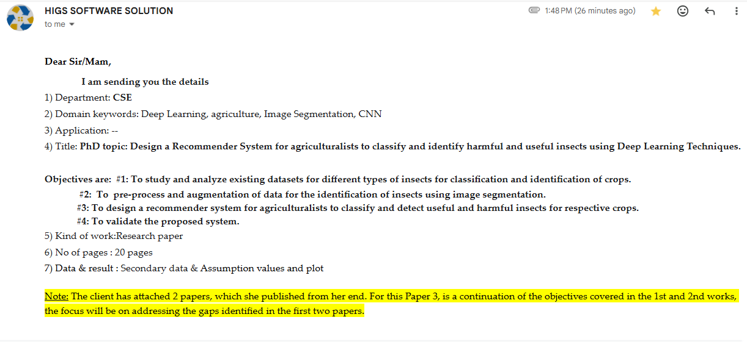
Title: Design a Recommender System for agriculturalists to classify and identify harmful and useful insects using Deep Learning Techniques.
Domain Keywords: Deep Learning, agriculture, Image Segmentation, CNN
Research Gap:
None of the prevailing agricultural insect identification methods learned the complementary relationship between handcrafted morphological features and rich visual representations between the harmful and beneficial insects. As the discriminative information from both feature types was not determined, making visually similar harmful and beneficial insect species difficult to distinguish and reducing classification accuracy. (Morphological-Visual Correlation Learning using HOG, DINO and CCA)
Problem Statement:
The prevailing work (2) focuses primarily on harmful insect detection and classification but does not provide pesticide recommendations after identifying the pest species. Thus, agriculturalists must rely on manual knowledge to select an appropriate pesticide, which may result in delayed pest management. (Solution: Pesticide Recommendation)
Tiny insect detection on crop leaves remains inaccurate due to cluttered backgrounds. Existing work (1) failed to distinguish very small insects from the input image, leading to improper insect detection. (Solution: Insect Localization)
Agricultural insect datasets are often highly imbalanced, and the traditional work (3) processes the image without balancing, causing biased output during classification. (Solution: Data balance)
In most of the prevailing works, images captured in agricultural fields often suffer from poor quality due to the presence of noise and low illumination, leading to degraded model performance. (Solution: Pre-processing)
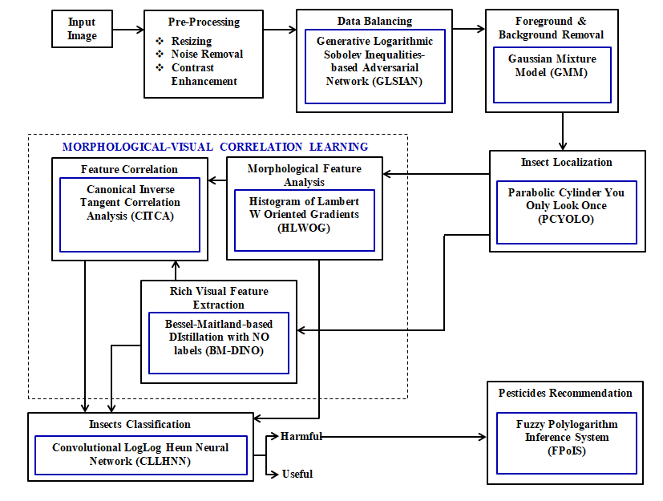
Figure: Block Diagram
Morphological Features: circularity, roundness, solidity, aspect ratio, convex area, hollowness, rectangularity, Rectangular Aspect Ratio, Ratio of Major Axis, Feret Major Axis, Feret Minor Axis, Convex Area Factor, Area-to-Length Ratio, Perimeter-to-Bounding Rectangle Ratio, Length-to-Perimeter Ratio, Circularity, Geometric Compactness, Area Compactness, Equivalent Perimeter Ratio, extent, elongation, orientation, bounding box area, and filled area.
Rich Visual Features: contrast, entropy, variance, sum average, sum variance, sum entropy, difference variance, difference entropy, mean intensity, standard deviation, variance, skewness, kurtosis, energy, homogeneity, correlation, dissimilarity, angular second moment, inverse difference moment, maximum probability, cluster shade, local binary pattern, texture coarseness, texture directionality, and texture roughness.
Algorithms used in the Proposed Framework:
Feature Correlation
The Canonical Correlation Analysis (CCA) is utilized to determine the correlation between the extracted morphological and rich visual features by identifying the maximally correlated feature projections from the two feature sets. CCA effectively eliminates redundant information and enhances the complementary characteristics of heterogeneous features, thereby improving the discriminative power of the combined feature representation. However, conventional CCA is sensitive to high-dimensional feature representations, which may lead to unstable correlation estimation. To avoid this limitation, the Inverse Tangent (IT) function is utilized in the correlation learning process to stabilize the correlation estimation between heterogeneous feature sets. Hence, the feature correlation method is referred as Canonical Inverse Tangent Correlation Analysis (CITCA).
Inverse Tangent function Ref: https://mathworld.wolfram.com/InverseTangent.html
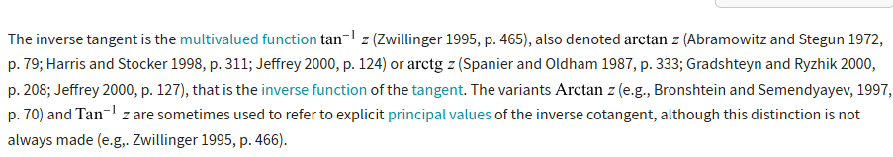
Morphological Feature Analysis
The Histogram of Oriented Gradients (HOG) is utilized to extract morphological features from the localized insect images by computing the distribution of edge orientations and local gradient information. HOG effectively captures the structural characteristics of insects, including their body shape, wing boundaries, and contour details, while being robust to moderate illumination and pose variations. However, HOG primarily relies on local gradient information and may fail to accurately represent complex nonlinear morphological variations among insect species with highly similar appearances. To overcome this limitation, the Lambert W function (LW) is introduced into the HOG feature transformation process to model nonlinear relationships among gradient descriptors and enhance feature representation. The LW function improves the representation of subtle morphological differences, resulting in more informative and discriminative shape features. Thus, the morphological feature analysis method is denoted as Histogram of Lambert W Oriented Gradients (HLWOG).
Lambert W function Ref: https://en.wikipedia.org/wiki/Lambert_W_function
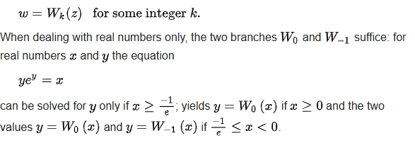
Rich Visual Feature Extraction
The DIstillation with NO labels (DINO) model is utilized to extract rich visual features from the localized insect images through self-supervised representation learning. DINO effectively captures semantic, texture, color, and structural characteristics without requiring manually annotated labels, thereby generating robust visual embeddings suitable for insect classification. However, DINO generally produces high-dimensional feature embeddings, which increase computational complexity and memory consumption during feature correlation and classification. To overcome this limitation, the Bessel-Maitland function (BM) is introduced to transform the high-dimensional embeddings into a more compact and discriminative feature representation while preserving essential visual characteristics. Therefore, the rich visual feature extraction method is denoted as Bessel-Maitland-based DIstillation with NO labels (BM-DINO).
Bessel-Maitland function Ref: Bessel–Maitland function
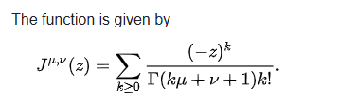
Insects Classification
The Convolutional Neural Network (CNN), which enables accurate insect classification, is performed. In CNN, the local receptive fields significantly reduce the number of trainable parameters, thereby improving computational efficiency and reducing memory requirements. On the other hand, the random initialization of network weights may lead to overfitting and poor convergence, thereby reducing the classification performance. Therefore, to overcome this limitation, the initial weights are tune using the Heun function which stabilizes the weights effectively. Furthermore, conventional activation functions may suffer from gradient saturation and reduced learning capability in deeper layers of the network. To address this issue, the LogLog activation function, which provides smooth nonlinear transformation and improved gradient propagation, is incorporated into CNN. Thus, the insect classification model is denoted as Convolutional LogLog Heun Neural Network (CLLHNN).
Heun function Ref: https://en.wikipedia.org/wiki/Heun_function
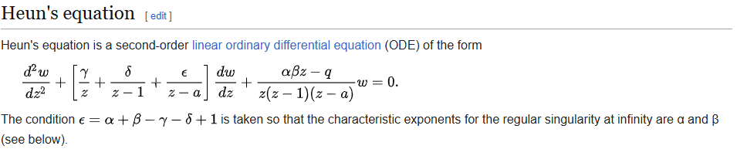
LogLog activation Ref: https://arxiv.org/abs/2402.09092
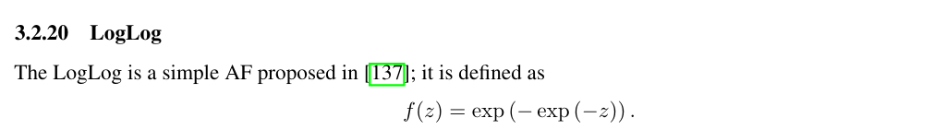
Pesticide Recommendation
The pesticide recommendation is determined using Fuzzy Inference System (FIS). The FIS provides adaptive pesticide recommendations according to the type of harmful insects. The FIA has the ability to make intelligent decisions under uncertain and imprecise conditions by utilizing linguistic variables and expert-defined if-then rules. However, conventional FIS employs fixed membership functions that may not accurately represent the nonlinear relationship between insect count and pesticide dosage, resulting in less precise recommendations. To overcome this limitation, the Polylogarithm-based membership function is included into the FIS to model the nonlinear variations in pest infestation more effectively. Thus, the pesticide with dosage recommendation model is termed as Fuzzy Polylogarithm Inference System (FPoIS).
Polylogarithm Ref: https://en.wikipedia.org/wiki/Polylogarithm
Insects Localization
To localize the insects, the You Only Look Once (YOLO) model, which detects insects from complex agricultural backgrounds by generating accurate bounding boxes for each insect, is utilized. YOLO has higher real-time processing capability. Yet, its localization performance may degrade when insects are very small. Therefore, the Parabolic Cylinder (PC) function is merged into the feature refinement stage of the YOLO framework. The PC function improves the representation of nonlinear feature variations and enhances the discriminative characteristics of insect regions, enabling YOLO to achieve more accurate localization of small and visually challenging insects. Thus, the insects localization model is named as Parabolic Cylinder You Only Look Once (PCYOLO).
Parabolic Cylinder Ref: https://en.wikipedia.org/wiki/Parabolic_cylinder_function
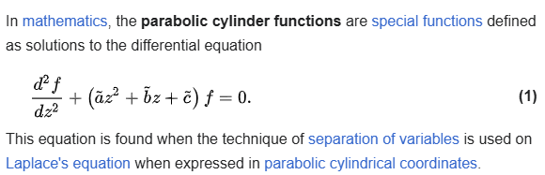
Data Balancing
The Generative Adversarial Network (GAN), which is effective in generating synthetic samples by learning the underlying data distribution through an adversarial learning process between the generator and discriminator, is employed to balance the insect image dataset. Data balancing improves the representation of minority insect classes and enhances the robustness of the following classification model. However, the adversarial training process of GAN is often unstable, leading to the generation of low-quality synthetic images that do not accurately represent the original data distribution. To address this limitation, Logarithmic Sobolev Inequalities (LSI) is included in the generator to regularize the learned probability distribution and promote smooth convergence during adversarial training. The LSI-based regularization improves the stability of the generator, enhances the diversity and quality of the synthesized insect images, and preserves the intrinsic characteristics of the original dataset. Therefore, the data balancing technique is referred as Generative Logarithmic Sobolev Inequalities-based Adversarial Network (GLSIAN).
Logarithmic Sobolev Inequalities Ref:
https://en.wikipedia.org/wiki/Logarithmic_Sobolev_inequalities
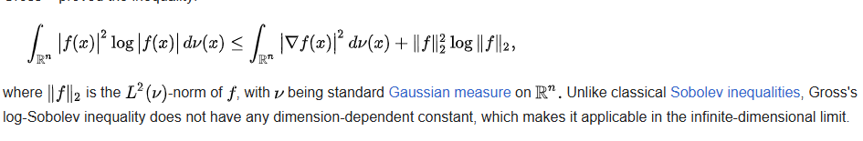
Foreground and Background Removal
Gaussian Mixture Model (GMM) is used to distinguish the foreground insect from the background by modeling the pixel intensity distribution using multiple Gaussian components. GMM effectively separates the object of interest from complex backgrounds, thereby reducing the influence of irrelevant regions and improving the quality of the forthcoming process. The extracted foreground insect enables more accurate insect localization, and morphological and visual feature analysis while minimizing background interference.
Pre-Processing
Resizing: Image resizing reduces computational complexity, and maintains consistency across the dataset, thereby improving the overall processing speed and model performance.
Noise Removal: Median Filter (MF) is applied to eliminate impulse noise and other unwanted artifacts while preserving important edge and boundary information of the insect. MF effectively suppresses salt-and-pepper noise without blurring object edges, resulting in improved image quality.
Contrast Enhancement: Adaptive Histogram Equalization (AHE) is utilized to improve the local contrast of the insect image by enhancing intensity variations in different image regions. AHE reveals fine structural details that may be hidden under non-uniform illumination, thereby improving the visibility of insect characteristics and increasing the discriminative capability of the extracted features for accurate classification and pesticide recommendation.
Dataset:
Pest and Pesticide: https://www.kaggle.com/datasets/shruthisindhura/pestopia
Useful Insects: https://www.kaggle.com/datasets/ismail703/insects
Insects’ segmentation by YOLO: https://www.kaggle.com/datasets/cubeai/insect-pest-detection-for-yolo
For Insects Classification:
Before Data Balancing:
Harmful insects: 56685 images
Useful insects: 5696 images
After Data Balancing:
Harmful insects: 56685 images
Useful insects: 56685 images
Result Metrics:
Primary Results | Secondary Results
Feature Correlation (CITCA): Correlation Coefficient, Redundancy Reduction (%), Wilks' Lambda  Morphological Feature Analysis (HLWOG): Fisher Score, Feature Extraction Time (ms), Mutual Information (bits)  Rich Visual Feature Extraction (BM-DINO): Silhouette Score, Davies-Bouldin Index (DBI), Calinski-Harabasz Index (CHI)  Insect Classification (CLLHNN): Accuracy (%), Precision (%), Recall (%), F-Measure (%) | Pesticide Recommendation (FPoIS): Fuzzification Time (ms), Defuzzification Time (ms), Rule Generation Time (ms)  Insect Localization (PCYOLO): mean Average Precision (%), Intersection over Union (IoU)  Data Balancing (GLSIAN): Inception Score, Structural Similarity Index Measure (SSIM)
References:
(1) Intelligent insecticide and fertilizer recommendation system based on TPF-CNN for smart farming - ScienceDirect
(2) Identify and classify pests in the agricultural sector using metaheuristics deep learning approach - ScienceDirect
(3) A novel few-shot self-supervised contrastive framework for UAV-based rare pest detection - ScienceDirect
DINO: https://aws.amazon.com/blogs/machine-learning/train-self-supervised-vision-transformers-on-overhead-imagery-with-amazon-sagemaker/
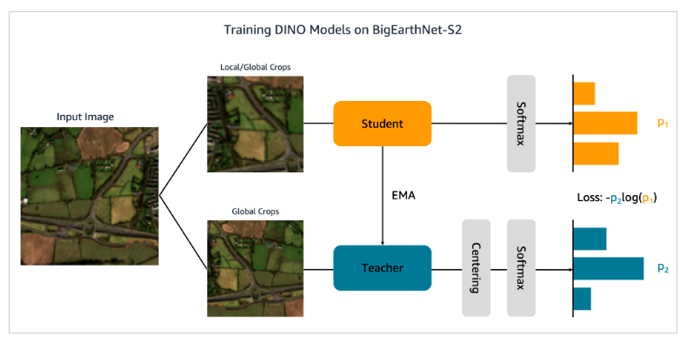
Correlation heatmap: How-Servant-Leadership-is-Effective-for-Employee-Performance-with-the-Use-of-t-Test-Algorithm-and-ANOVA.pdf
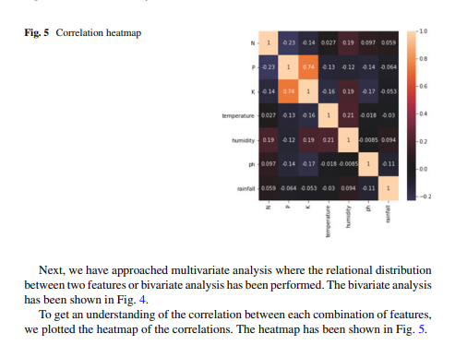
Background removal and YOLO: https://link.springer.com/article/10.1038/s41598-025-20331-z?fromPaywallRec=true
https://www.researchgate.net/publication/336423148_Moving_Target_Detection_Based_on_Improved_Gaussian_Mixture_Background_Subtraction_in_Video_Images
Oriented Gradients: https://www.nature.com/articles/s41598-024-83012-3.pdf
